NAME: |  | DATE:

PRACTICE EXERCISE # 1

- LE4_11.c

START
- INITIALIZE inputLetter
- PROMPT and READ "Enter a letter: ", inputLetter

- IF inputLetter is a letter (A-Z or a-z) then
3.1 IF inputLetter is uppercase (A-Z) then
convert inputLetter to lowercase
3.3 ENDIF
3.4 IF inputLetter is a vowel (a, e, i, o, or u) then
DISPLAY "VOWEL!"
3.6 ELSE
DISPLAY "CONSONANT!"
3.8 ENDIF

- ELSE
DISPLAY "INVALID INPUT!"
4.1 ENDIF
- DISPLAY "=========================================="
END / STOP

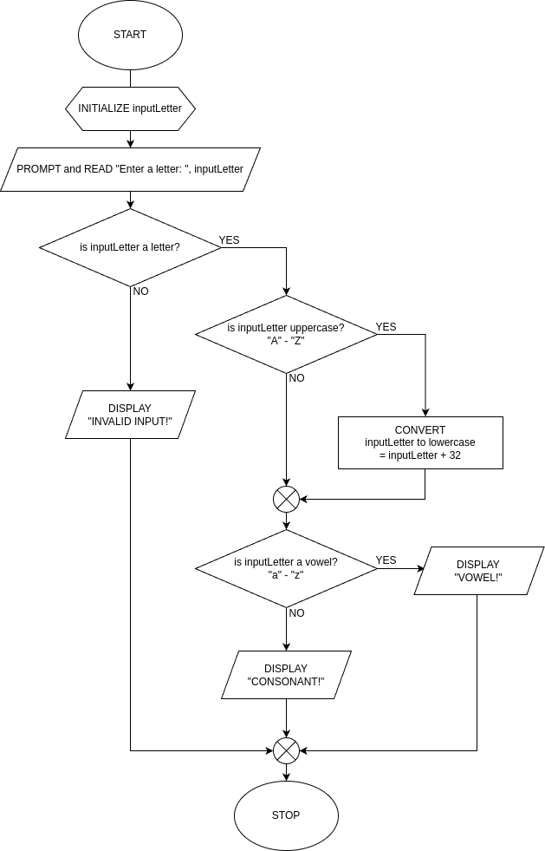

LE4_11.c Flowchart

- LE4_12.c

START
1. INITIALIZE a, b, c as double
2. PROMPT and READ “Enter the coefficient a: “, a
2.1 IF input is not a valid number
DISPLAY “Invalid Input.”
2.2 ENDIF
3. PROMPT and READ “Enter the coefficient b: “,b
3.1 IF input is not a valid number
DISPLAY “Invalid Input.”
3.2 ENDIF
4. PROMPT and READ “Enter the coefficient c: “, c
4.1 IF input is not a valid number
DISPLAY “Invalid Input.”
4.2 ENDIF

5. IF a = 0 and b = 0
DISPLAY “No Solution.”
5.2 ENDIF
6. IF a = 0
solve root = -c / b
DISPLAY “One root: %.2f“, root (2 decimal place)
6.2 ELSE
COMPUTE for discriminant = b * b – 4 * a * c;

6.3 IF discriminant < 0
DISPLAY “No real roots.”
6.4 ELSE IF discriminant = 0
COMPUTE for root = -b / (2 * a)
DISPLAY “One root %.2f”, root
6.5 ELSE
COMPUTE root1 = (-b + sqrt(discriminant)) / 2 * a)
COMPUTE root2 = (-b – sqrt(discriminant)) / 2 * a)
DISPLAY “Two real roots:”
DISPLAY “Root 1: %.2f”, root1
DISPLAY “Root 2: %.2f”, root2
END

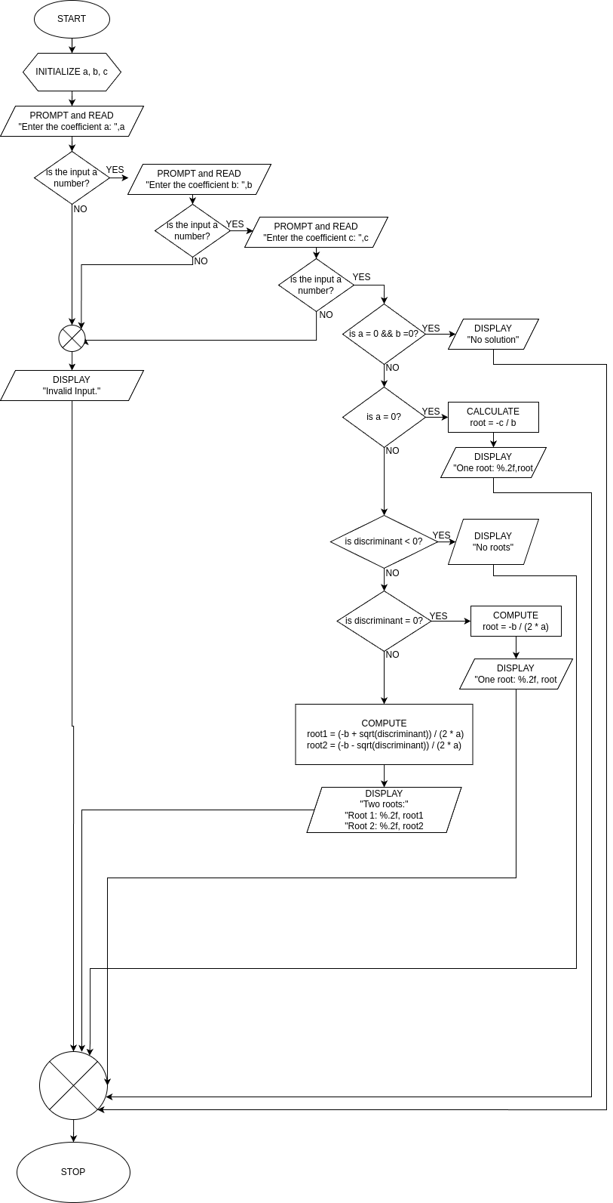

LE4_12.c Flowchart

- LE4_13.c

START
1. INITIALIZE mark1, mark2, mark3, mark4
2. PROMPT and DISPLAY “1st Mark : “,mark1
3. PROMPT and DISPLAY “2nd Mark : “,mark2
4. PROMPT and DISPLAY “3rd Mark : “,mark3
5. PROMPT and DISPLAY “4th Mark : “,mark4
6. IF mark1 < 0 or mark1 > 100 or mark2 < 0 or mark2 > 100 or mark3 < 0 or mark3 > 100 or
mark4 < 0 or mark4 > 100
DISPLAY “Invalid input.”
6.1 ELSE
COMPUTE finalGrade = (mark1 + mark2 + mark3 + mark4) / 4
6.1 DISPLAY “FINAL GRADE: %.2f\tREMARKS : “, finalGrade
6.2 IF finalGrade >= 50
DISPLAY “PASSED”
6.3 ELSE
DISPLAY “FAILED”
END

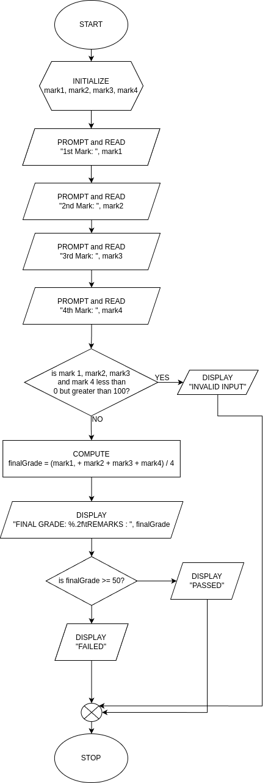

LE4_13.c Flowchart

